

DISASTER RISK REDUCTION & LIVELIHOODS END OF PROJECT REPORT

Name of Project: | SI Flooding – UNDP Disaster Risk Reduction & Livelihoods | Project Number: | S201956
To: | UNDP | From: | World Vision - DRR/Livelihoods Project Coordinator (Freda Folasi)
Project Starting Period: | March 2015. | Project Completion Period: | January 31st 2016

1. ACCOMPLISHMENTS OF LAST 11 MONTH’S TASKS: (Activities, Tasks, and Variances)

Log frame Code | Activity Objectives | Tasks | Accomplishment | Variance and Plan to address
03.01.01 | 20 communities are trained on Disaster Risk Reduction (DRR) and undergo Simulation exercise | The DRR/Livelihood Project Coordinator, DRR Technical Trainer and the Project Facilitator to provide DRR Trainings for 20 project communities | Team has conducted 20 disaster risk management training in 20 communities | This activity is complete.
03.01.02 | 20 Communities are provided with follow up training on DRR | The DRR/Livelihood project Coordinator, DRR Technical Trainer and the project Facilitator to provide follow up training on DRR for the 20 communities | Team has conducted 20 followup training | This activity is complete.
03.01.03 | 20 Communities are provided with training and undertake a disaster simulation exercise | The DRR/Livelihood Project Coordinator, DRR Technical Trainer and the Project Facilitator to provide training and exercise on Emergency Simulation | Team has conducted 20 simulation exercises with the 20 communities | This activity is complete.
03.01.04 | DRR IEC materials provided to 20 communities | The DRR/Livelihood Project Coordinator, Trainer, the Project Facilitator and the casual staff provided DRR IEC materials to 20 project communities | The 20 communities have received 1000 IEC materials on 5 hazards, Flooding, Landslide, Earthquake, Cyclone, Fire | This activity is complete .
03.01.05 | 20 community DRR committees are established to manage DRR activities and livestock | The DRR/Livelihood Project Coordinator, and the Project Facilitator to support communities to setup 20 community DRR committees to manage DRR activities and livestock | The team has supported the 20 communities in establishing of their 20 disaster committees and they are still active now. | This activity is complete .
4.01.01 | An initial meeting and livestock assessment is conducted in 20 communities | The DRR/Livelihood Project Coordinator, the Project Facilitator, casual staff community mobilizer with support from Community Economic Development (CED) technical staff have conducted 20 community awareness and assessments in the 20 project communities | Team has conducted 20 community assessment in the 20 communities | This activity is complete.
04.01.02 | 20 Communities are trained on livestock management | The DRR/Livelihood Project Coordinator, and the Project Facilitator to find technical person to provides livestock management training to the 20 communities | Team has engaged one technical livestock trainer from Ministry of Agriculture & Livestock to conduct training. Broiler management for 9 chciken communities and Pig Husbandry for 11 pig communities | This activity is complete
04.01.03 | 20 Communities are provided with livestock | The DRR/Livelihood Project Coordinator, and the Project Facilitator with support from the CED technical staff to provide livestock for the 20 communities | The 20 communities have received their livestock.  11- Pig  9 – Chicks/Broilers  - Ghautina – 200  - Papaga – 200  - New Tenabuti – 200  - Gesa – 200  - Crusher – 200  - Tetupa – 200  - Luluga – 200  - Komukama – 200  - Vatilau - 200 | This is activity is complete
04.01.04 | 20 communities are provided with necessary housing for livestock | The DRR/Livelihood project Coordinator, and the Project Facilitator with support from the CED technical staff to provide necessary housing for the livestock | The 20 communities have reccieved materials for their livestock housings | This activity is complete
05.01.01 | WVSI works with livelihoods cluster partners to produce a report into the livelihoods aspect of the 2014 flood response. | The DRR/Livelihood project Coordinator, and the Project Facilitator with support from the DME team to conduct livelihood cluster research with livelihood cluster stakeholders | Cluster report completed  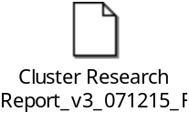 | This activity is complete .
06.01.01 | WVSI conducts regular monthly monitoring and produces short evaluation report. | The DRR/Livelihood project Coordinator, and the Project Facilitator with support from the DME team to conduct end of project evaluation with project communities | Evaluation report completed  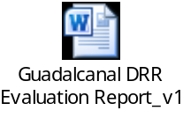 | This activity is complete .

2. REPORT ON THE IMPACT OF THE PROJECT:
- Communities participated in the Simulation exercises shows that they have acquired new knowledge and that they are prepared for future disasters.
- Providing local materials and land, labour for their livestock housing shows the commitment of the communities in the project.

3. OBSERVATION, LEARNING AND KEY CHANGES NEEDED (Please describe any observations and learning on the project’s activities and what you need to change in the project as a result – this needs to include clear action points for change).
- Our observation during the past eleven months was the activities are progressing well. Feedback from the 20 communities indicate their commitment towards the project both by verbal acknowledgement, by providing local materials, land and labour, and by their active participation during the implementation of activities in their communities.
- Livestock inputs have been well-received by community members, and have really supported them to start up savings group in some communities
- The main learning is the need to engage a technical person when conducting future community livestock assessment. This will enable community members to select livestock that can be easily managed and reproduced.
- In terms of staffing, it is recommended that to properly work with 20 communities then there should be a total of 3 Community Develoment Facilitators (currently there is only one).

4. CRITICAL ISSUES/CHALLENGES:
- Weather
- This is one of the most challenging issue faced by the team during the implementation of the planned activities in the 20 communities, this results in delay in constructing livestock housings
- Postpone activities due to bad weather (DRR trainings/ Livestock trainings)
- Late Distribution of livestock housing materials to the 16 communities
- Monitoring visits to communities not done on time
- Livestock providers were not consistent in providing the livestock after payments done (MAL/ Tenavatu Cattle Farmers)
- Project Team was not orientated on the donor Financial reporting requirements, so the team needed to halt activities to work on donor acquittals thus requested no-cost extension in order to complete remaining project activities
- One issue which we have faced is the two (2) staffs only to implement the project in 20 communities for nine (9) months is the most challenging thing when it comes to mobilising communities
- The bad weather disrupts plan activities in the communities and this also affects the construction of the livestock pens and fences

UNDP - DRR/LIVELIHOOD 20 TARGET COMMUNITIES SUMMARY DATA
No. | Name of Community | WARD | Total H H | Total Population | Livestock Need
1 | NEW KOLINA 1,2,3,4 | MALANGO | 46 | 210 | PIG
2 | CRUSHER | MALANGO | 60 | 141 | CHICKEN
3 | POULTRY | GHAOBATA | 8 | 46 | PIG
4 | SAPE | GHAOBATA | 5 | 39 | PIG
5 | RARA | GHAOBATA | 15 | 106 | PIG
6 | KOLEASI | VULOLO | 60 | 279 | PIG
7 | TETUPA | VULOLO | 34 | 166 | CHICKEN
8 | LULUGA | PARIPAO | 66 | 315 | CHICKEN
9 | VATILAU | PARIPAO | 12 | 59 | CHICKEN
10 | NEW TENABUTI | PARIPAO | 119 | 512 | CHICKEN
11 | NUMBU | PARIPAO | 154 | 681 | PIG
12 | MAGIA | PARIPAO | 24 | 110 | PIG
13 | VATUNIOGO/KAPISA | PARIPAO | 22 | 84 | PIG
14 | ALALU | PARIPAO | 9 | 47 | PIG
15 | GESA | PARIPAO | 66 | 322 | CHICKEN
16 | HAUTINA | VULOLO | 49 | 242 | CHICKEN
17 | KOMUKAMA | PARIPAO | 83 | 445 | CHICKEN
18 | PAPAGA | PARIPAO | 31 | 141 | CHICKEN
19 | DADAE | PARIPAO | 18 | 151 | PIG
20 | POPOLOI/KOLINA 3 | GHAOBATA | 14 | 65 | PIG
 | TOTAL |  | 921 | 4161

6. PHOTOS OF PROJECT ACTIVITIES.

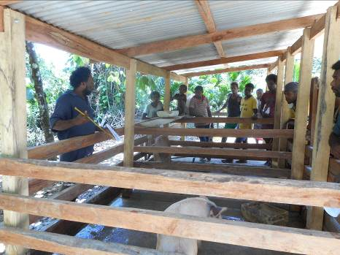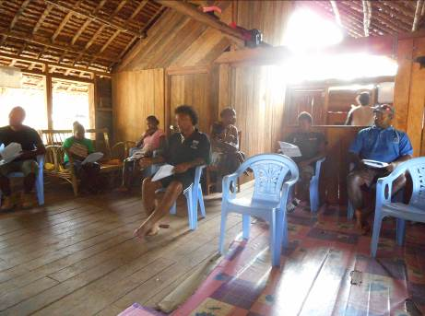
Fig 1: Livestock Trainer with participants practical session Fig 2: Participants during livetock trainng on broiler management

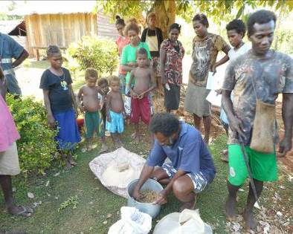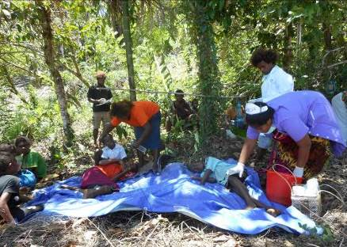
Fig 3: Livestock trainer display how to mix good balance diet for pigs Fig 4: Mock simulation exercise and nurse attends to injured victims

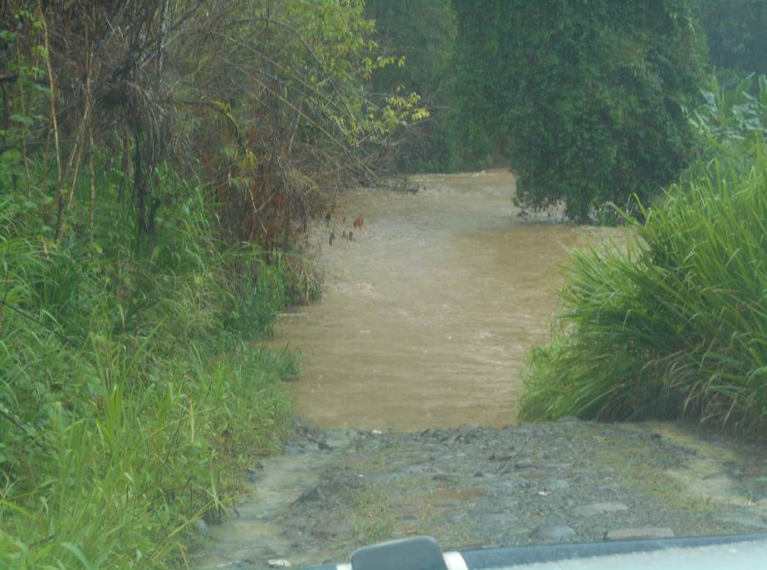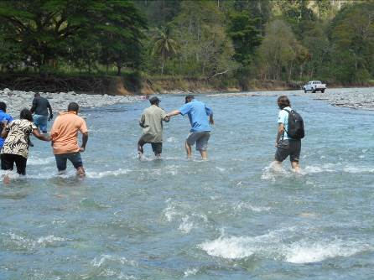
Fig 5: Roads are flooded and disturbs monitoring visits Fig 6: Crossing strong current river for mock simulation for key stakeholders

